**Api Documentation**

**Flutter Assignment**

1. **GET: https://dev2be.oruphones.com/api/v1/global/assignment/getListings**

This endpoint is used to retrieve a list of phone listings based on pagination.

**Request Method**: GET

**Endpoint**: **/**api/v1/global/assignment/getListings

**Parameters**:

page (number, required): The page number for pagination. Default is 1.

limit (number, required): The maximum number of listings per page. Default is 10.

**Example Request (Postman Screenshot) :-**

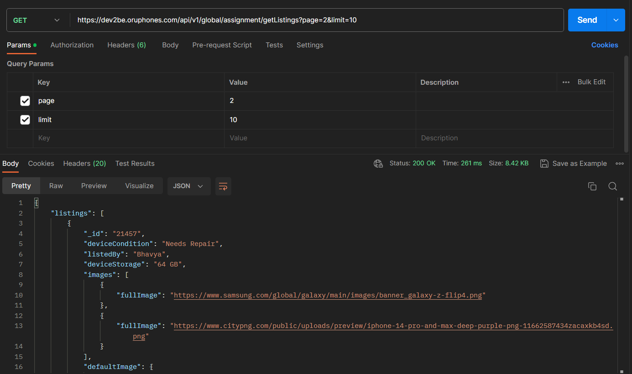

Note :- The above parameters should be passed in params

1. **GET: https://dev2be.oruphones.com/api/v1/global/assignment/getFilters**

This endpoint is used to retrieve filters for phone listings.

**Request Method:** GET

**Endpoint**: /api/v1/global/assignment/getFilters

**Parameters:**

isLimited (boolean, optional): Indicates whether to fetch limited filters or all filters. Default is true.

**Example Request (Postman Screenshot) :-**

Note :- The above paramets should be passed as params

1. **POST: https://dev2be.oruphones.com/api/v1/global/assignment/searchModel**

This endpoint is used to search for phone models.

**Request Method**: POST

**Endpoint**: /api/v1/global/assignment/searchModel

**Request Body**: searchModel (string, required): The phone model to search for.

**Example Request (Postman ScreenShot):**

Note :- The above parameters should be passed in body of http request

**Please note that the actual response data for each endpoint may vary based on the payload you send**